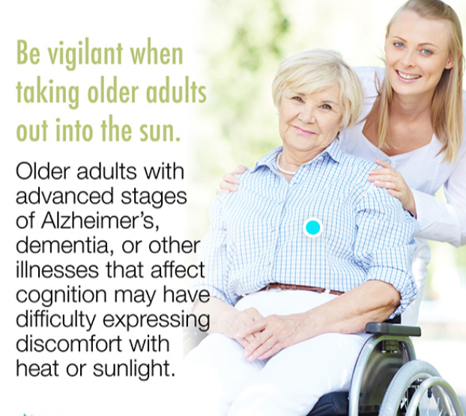

The Ministry of Health requires that homes have a heat policy in place, which includes limiting access to the outdoors when the humidex is over 30 degrees. On these days, we post signs to let you know that visits should take place indoors.  Residents exposed to a sudden change in temperature when going outdoors may experience hot weather related illnesses due to an impairment of the body’s ability to regulate temperature.

When taking your loved one outside please be sure to have them put on sunscreen and wear a sunhat.  Sunscreen is available at the exit from the Home or from the registered staff.  Extra beverages are important at this time of year.  Ice water is always available in our serveries. Please ensure your loved one is dressed appropriately for the weather and seek shade whenever possible.  If you do choose to go outside on a hot day, please limit the time to 30 minutes or less.

The air handling system in this building is effective in keeping us comfortable. In the common areas including the hallways, dining rooms, living rooms, etc., the HVAC system provides air conditioning and heating. Resident’s bedrooms receive “tempered air” monitored and controlled by a building automated system.  Roof top units supply air that cools to a consistent temperature with this system.  This eliminates the steady stream of cold air that air conditioning provides. During hot summer days, we ask residents to keep their bedroom windows closed as the heat coming in can drastically raise the temperature.  If you feel the need to open the window then you must close the bedroom door to avoid circulating the warm temperatures into the hallways. Also, please consider closing the blind as well to limit the direct sunlight.